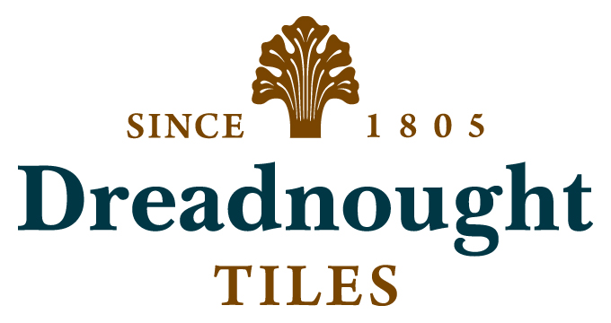 | Dreadnought Clay Roof Tiles  Tel: 01384 77405  www.dreadnought-tiles.co.uk  office@dreadnought-tiles.co.uk
To complete the clause, select the appropriate wording from below. Highlighted text can be ‘dragged and dropped’ to save typing.
H60 PLAIN ROOF TILING
780 MORTAR BEDDED MONO-RIDGES
Dreadnought Ridge Tiles.
A range of mono ridge tiles in a smoothfaced or sandfaced finish. The natural burnt clay colours are produced entirely by control of the kiln atmosphere and without the use of colouring agents. These colours are permanent and unaffected by exposure to UHV light.
All products comply with BS EN 1304.
Two types are available:
Half round mono ridge 300mm length.
Angle mono ridge 300mm length.
The roof pitch must be quoted when ordering.
Consult with Dreadnought Tiles technical literature for details. Hinton, Perry & Davenhill Ltd can also provide a design and specification service and it is recommended that they are consulted early in the design process.
Mono ridge tiles:
Manufacturer: Hinton, Perry & Davenhill Ltd, Dreadnought Works, Pensnett, Brierley Hill, West Midlands, DY5 4TH. Tel: 01384 77405. Fax: 01384 74553. Email: office@dreadnought-tiles.co.uk Web: www.dreadnought-tiles.co.uk
Product reference:
Dreadnought Clay Half Round Mono Ridge Tiles Ref: RMHR.
Dreadnought Clay Angle Mono Ridge Tiles Ref: RMAR.
Colour:
To match roof tiles.
Sandfaced finishes:
Red Sandfaced / Brown Heather Sandfaced / Red-Blue Blend Sandfaced / Brown Antique Sandfaced / Staffs Blue Sandfaced / Dark Heather Sandfaced
Smoothfaced finishes:
Red Smoothfaced / Plum Red Smoothfaced / Brown Brindle Smoothfaced / Red-Blue Blend Smoothfaced / Brown Antique Smoothfaced / Blue Brindle Smoothfaced / Staffs Blue Smoothfaced
Pitch: 35° / 40° / 45° / 50°
Standard pitches. Consult with Dreadnought for availability of alternatives.

