


13

Declaration of Performance

- Unique identification of product type:
Ketley Quarry Tile
Group HD, Category II, 215x102.5x18mm Clay Masonry Units

- Type, batch or serial number or any other element allowing identification of the construction product as required under Article 11(4):
KPT

- Intended use or uses of the construction product in accordance with the applicable harmonised technical specification as foreseen by the manufacturer:
Clay Quarry tiles for internal and external uses for rigid forms of construction

- Name, registered trade name or registered trade mark and contact address of the manufacturer as required under Article 11(5):
Ketley Brick Company Ltd, Dreadnought Works, Pensnett, Brierley Hill, West Midlands. DY5 4TH

- System or sytems of assessment and verification of constancy of performance of the construction product as set out in Annex V:
System 4

- Declared performance:

Essential Characteristics | Performance | Harmonised Technical Specification
Dimensions and Dimensional Tolerances | Meets Requirements  For extruded tiles Group A1b | BS EN 14411:2012
Water Absorption | ≤3.0% | BS EN 14411:2012
Frost Resistance | Complies after 100 cycles | BS EN 14411:2012
Breaking Strength | ≥1100 N | BS EN 14411:2012
Slip/Skid resistance  (Pendulum) | Rz Value 20+μm  PTV Value 36+  (Low Slip Potential) | BS 7976-2:2002
Stain Resistance | Minimum Class 3 | BS EN 14411:2012
Deep Abrasion Resistance(Unglazed) | ≤275mm³ | BS EN 14411:2012
Slip Resistance  (Wet Barefoot Ramp) | Category C | DIN 51097:1992
Slip Resistance  (Shod Ramp) | R11 | DIN 51130:2010

- The performance of the product identified in points 1& 2 is in conformity with the declared performance in point 6.

This declaration of performance is issued under the sole responsibility of the manufacturer identified in point 4.

Signed for and on behalf of the manufacturer:

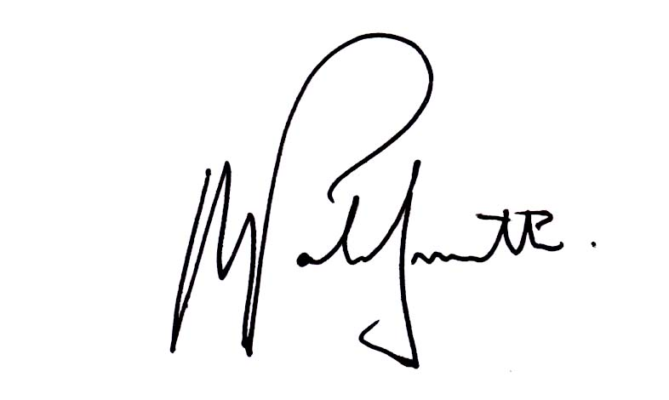
Name: Alex Patrick-Smith

Signed: Date: 09.05.2016

