


13

Declaration of Performance

Unique identification of product type:
Ketley Staffordshire Brown Brindle Smooth Brick Slip Pistol Return
Group HD,Category II, Clay Masonry Units,
215x65x15 (LxHxW) Stretcher
102.5x65x15 (LxHxW) Header

- Type, batch or serial number or any other element allowing identification of the construction product as required under Article 11(4):
KPSR15BRB

- Intended use or uses of the construction product in accordance with the applicable harmonised technical specification as foreseen by the manufacturer:

Suitable for external and internal brick cladding

- Name, registered trade name or registered trade mark and contact address of the manufacturer as required under Article 11(5):
Ketley Brick Company Ltd, Dreadnought Works, Pensnett,
Brierley Hill, West Midlands. DY5 4TH

- System or systems of assessment and verification of constancy of performance of the construction product as set out in Annex V:
System 4

- Declared performance:

Essential Characteristics | Performance | Harmonised Technical Specification
Dimensions and Dimensional Tolerances | Complies  Tolerance Class T2 Range Class R1 | EN771-1:2011
Active Soluble Salts | Class S2 | EN771-1:2011
Reaction to Fire | Class A1 | Commission Decision 2000/605/EC
Water Absorption | <4.5% | EN771-1:2011
Durability Against Freeze Thaw | F2 | EN771-1:2011
Dangerous Substances | NPD | EN771-1:2011

- The performance of the product identified in points 1 and 2 is in conformity with the declared performance in point 6.

This declaration of performance is issued under the sole responsibility of the manufacturer identified in point 4.

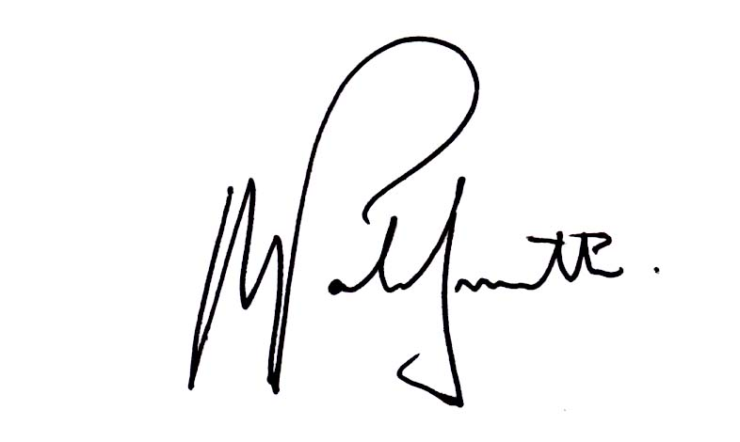
Signed for and on behalf of the manufacturer:

Name: Alex Patrick-Smith

Signed: Date: 08:09:2016

:

Ketley Brick Ltd, Dreadnought Works, Dreadnought Road, Pensnett, Brierley Hill, West Midlands DY5 4TH www.ketley-brick.co.uk

